|  |
| --- |
| American Video Gaming Company |
| Software Project |
| C188 Performance Assessment |

|  |
| --- |
| Dainen Mann  11-8-2022  [Version 1.0] |

Contents

A. Introduction 3

A.1. Purpose Statement 3

A.2. Overview of the Problem 3

A.3. Goals and Objectives 3

A.4. Prerequisites 3

A.5. Scope 3

A.6. Environment 3

B. Requirements 5

B.1. Business Requirements 5

B.2. User Requirements 5

B.3. Functional Requirements 5

B.4. NonFunctional Requirements 5

C. SOFTWARE DEVELOPMENT METHODOLOGY 7

C.1. Advantages of the Waterfall method 7

C.2. Disadvantages of the Waterfall method 7

C.3. Advantages of the Agile Method 7

C.4. Disadvantages of The Agile Method 7

C.5. Best Suited 7

D. Design 9

D.1. Flowchart 9

D.2. UML Diagram (Change title to fit needs) 10

E. Testing 11

E.1. Functional, Performance, and Compatibility Testing 11

E.1.1. Contact Creation 11

E.1.2. Operating System and Browser Support 12

E.1.3. Hard Delete Function 13

F. Sources 15

# Introduction

The American Video Game Company’s sales are increasing at a high rate and are outgrowing its current architecture. This proposal will detail the needs and goals of a Customer Relationship Management system with plans for integration. Finally, testing will be done on different aspects to ensure functionality and compatibility

# A.1. Purpose Statement

The purpose is to provide an in-depth, cost-effective, and intuitive solution for a new CRM tool that will fit the needs of the American Video Game Company’s increasing growth

# A.2. Overview of the Problem

The company is rapidly growing in business with a 42% increase in sales in the past two years and is in dire need of new software architecture. This proposal will provide a tool to manage many concurrent users, provide software and browser support for all hardware within the company, contact management, a ticketing system, and the ability to restrict how data is managed

# A.3. Goals and Objectives

The key goals of this project are to consolidate business contact information, control access to data, integrate a new CRM that will work smoothly with old architecture and set up a server system to host at least 2000 users

# A.4. Prerequisites

Requirements need to be approved by leadership to ensure the proposed solution is exactly what the company needs/wants. After requirements are approved, budget and schedule expectations need to be defined to ensure the benefits outweigh the risks. While waiting for approval on a budget/schedule, it wouldn’t hurt to check IT security and update if needed

|  |  |  |  |
| --- | --- | --- | --- |
| Number | Prerequisite | Description | Completion Date |
| 1 | N/A | Requirements approval by company leadership | 11/15/2022 |
| 2 | 1 | Budget and time constraints approved | 11/20/2022 |
| 3 | 1 | Company IT infrastructure security up to date | 12/1/2022 |

# A.5. Scope

This document will describe user and business requirements, functional and non-functional. We describe the environment, software compatibility and functionality, and technical details along with a software solution and its architecture. Finally, we provide a testing plan for this software.

# A.6. Environment

The system must be compatible with current operating systems and browser versions. The list of browsers and operating systems will be listed in the sections below. The server will be hosted on enterprise-class server hardware (enough power to handle high traffic). There is an existing active directory server that the system must integrate with. Existing hardware within the company should be able to access the new software after updating and testing is complete

# Requirements

The proposed CRM will cover five requirements in this document below:

* Users
* Contact Management
* “Soft and Hard” delete
* Ticketing System
* OS and Browser support

# Business Requirements

The proposed solution will cover contact management. Contact management requires conditions on how a contact may or may not be contacted. There are also requirements on how a contact’s details will be used. The CRM will allow contacts to manage contact settings and preferences. It will also manage records by tagging and categorizing them by type

# User Requirements

American Video Game Company will need a system that can handle 2,000 users and an average of 500 users concurrently. It must also include scalability to handle the growth of the company. The proposed solution is to use enterprise-class server hardware on-site to handle traffic and a database to handle the sorting and organization of customer data.

The CRM will need all hardware to be updated to the most current operating systems and browsers. All existing machines within the company will be tested for compatibility before deployment. Below are the listed requirements:

* latest Chrome and Chromium
* latest Firefox
* latest Microsoft Edge (Internet explorer to be phased out)
* Safari 16
* Windows 10/11
* mobile & tablet
* iOS16 Safari
* iOS16 Third Party Browsers (Chrome and Firefox)
* Android 4.0 Chrome

# Functional Requirements

The proposed CRM will support the ability to “soft and hard delete” data. Access and permissions to data will be managed by managers and administrators. The soft deletion function will be in place for users to remove data from their view without actually deleting the data from the database, this is a low-risk function that most anyone can do. On the other hand, the hard deletion function will require access and permissions to the database where records will be updated or deleted

# NonFunctional Requirements

The database included is going to require a ticketing system that can leave an audit trail by tracking a user’s relevant details, including who called, the reason, and the date/time. The proposed CRM will include this system that will track customer and sales data to a specific ticket. This will pair with user management to create a function that will resolve issues rapidly. The ticketing system will perform the following:

* Date and time a user accesses a ticket
* A search function that will track past tickets
* Creation of new unique tickets that will be added to the CRM database

# SOFTWARE DEVELOPMENT METHODOLOGY

The company has selected the waterfall software development methodology for this project. The waterfall method is a well-known predictive development model widely used by expert teams. The proposed solution will be broken down into steps that will be completed sequentially.

# Advantages of the Waterfall method

The waterfall method has several different advantages:

* You have a clear estimation of when the project will finish and how much it will cost
* Everything is predicted beforehand, the project won’t change much during the development
* The requirements are clear, the end-user will know what they are getting
* If executed correctly, may result in a higher-quality product

# Disadvantages of the Waterfall method

The waterfall method also comes with several disadvantages:

* The whole project needs to be defined from the start. Since each step needs to be done sequentially, some team members may be done with their suggestions and work on one step, others will not
* A predictive project will lack flexibility. Requirements could change, and accommodating these changes could be quite difficult
* Everything will be deployed at once, users will not get a full, working version until all the work has been completed

# Advantages of the Agile Method

The Agile method is another methodology that could potentially be used, here are several different advantages (Adobe Communications Team, 2022):

* Agile revisits steps and rewrites until desired results are achieved
* Project scope can be maintained from changes with frequent delivery of the product
* Agile projects tasks are tested during production, allowing for a faster and better product

# Disadvantages of The Agile Method

There are also several different disadvantages (Adobe Communications Team, 2022):

* A change in project requirements could cause problems within the organization
* No strict schedule. If time is not managed efficiently, delivering under a tight deadline could prove fatal
* Agile needs a consistent team, any weak links could result in wasted time and money

# Best Suited

The waterfall method should perform best here since all the requirements are known beforehand in detail (provided by a CRM requirements document), and each step can be done sequentially without difficulty. Given the detail of each step, an estimation of labor, cost and time can be predicted accurately. With the entire project predicted, each step can be completely done without much risk and will ensure a higher quality product. The American Video Game Company can expect to get exactly what they need/want if the project goes accordingly.

# Design

The American Video Game Company will be able to customize the overall desired experience. This system will be integrated into their existing directory system. The following design models will show the basics and relationships of the CRM with contact and user management alongside a ticketing system.

# Flowchart

This is an example flowchart detailing how a customer is generated or a user can input their information through a sign-in or ticket system. The user can search and edit their information/ticket depending on their access level.

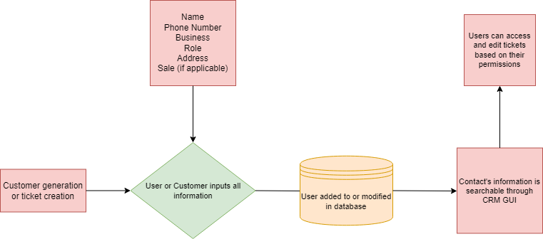

Figure : Sample Flowchart

# UML Diagram (Change title to fit needs)

This is an ERD (Entity-Relationship Diagram) to show relations between customers, orders, and tickets in the database and represents components of contact management and ticketing system.

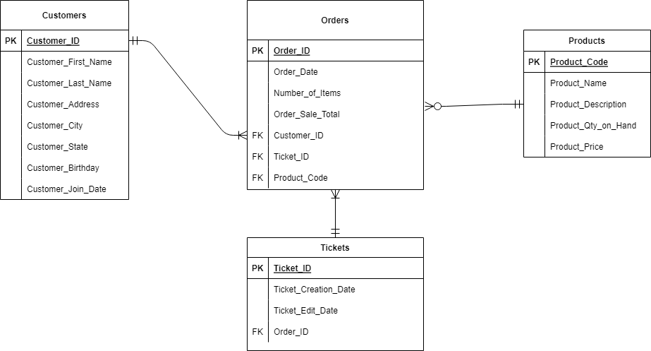

Figure : Sample Database

# Testing

Testing will focus on three critical functions to ensure no interruptions during deployment, listed below:

* Creating a contact and reflecting data added to the database
* Operating system and browser support
* Hard delete functionality

# Functional, Performance, and Compatibility Testing

First on the list is contact creation, a functional test will be used to ensure creating contacts works as expected. The second, and most extensive, is the operating system and browser support. This is where a compatibility test will be run repeatedly on several computers within the company. After, a performance test will be run on the server to ensure the server’s high traffic load can be handled. Third, another functional test will determine if the hard delete functionality works

# Contact Creation

|  |
| --- |
| Requirement to be tested  Creating a new contact |
| Preconditions: Conditions that must be present before test case can successfully run  Database, GUI, schemas, and APIs must be present before testing |
| Steps: The steps the tester must execute to test the feature.   1. Create a test user with random information 2. Create new contact using the GUI 3. Enter user information and save 4. Ensure there are no errors generated 5. Query and open contact information, match with step 1 user information |
| Expected results: Expected results and any side effects such as updating a database, writing to a file, etc.  The expected result is a basic input of information that should reflect the user’s data. This should write to or update any tables/files in the database and a query should return values that match fake user data |
| Pass/Fail: Mark whether the test case passed or failed. The results can be compiled and used to determine if the application is ready for delivery/release.  Passed. A query was used to search for the results, this returned values that matched the data used for the fake test user. No errors were generated with the contact creation |

# Operating System and Browser Support

|  |
| --- |
| Requirement to be tested  The CRM needs to be supported by a variety of browsers and operating systems. A functional server, that can handle high traffic, also needs to be present |
| Preconditions: Conditions that must be present before test case can successfully run  Below are the browsers that need to be updated company-wide to ensure compatibility, this will be tested on all machines. The server hosting the CRM also needs to be set up and functional.   * Chrome and Chromium * Firefox * Microsoft Edge * Windows 10/11 * Safari/iOS Safari * iOS third-party browsers * Android Chrome |
| Steps: The steps the tester must execute to test the feature.   1. The application and any supporting materials will be installed on an updated admin computer to ensure the CRM is compatible 2. Execute and run CRM software, overall system test and check for bugs and errors 3. Test for integration with old architecture 4. If all goes well, redo steps 1-3 with an increasing amount of computers 5. After step 4 is complete, stress test the server with a high number of users |
| Expected results: Expected results and any side effects such as updating a database, writing to a file, etc.  Updating browsers and operating systems should go quickly and smoothly, with a possible risk of current hardware needing an upgrade. Compatibility may run into hiccups with the amount of different hardware to test the new software. Overall, the benefit should outweigh the risk from the previously stated points |
| Pass/Fail: Mark whether the test case passed or failed. The results can be compiled and used to determine if the application is ready for delivery/release.  This test case passed. Some hardware needed to be replaced/upgraded, but overall, each computer accommodated the new software. A side benefit is the company is now current on their technology |

# Hard Delete Function

|  |
| --- |
| Requirement to be tested  Hard deleting data |
| Preconditions: Conditions that must be present before test case can successfully run  Database, GUI, schemas, and APIs must be present before testing. Test data must be already existing within the database. Access and permissions exist for current users |
| Steps: The steps the tester must execute to test the feature.   1. Use software GUI or use database query function to find test data 2. Delete using software or database functions 3. Confirm the successful deletion by seeing correct fields were removed 4. Examine logs to see if the records of the user who deleted the data was reflected correctly |
| Expected results: Expected results and any side effects such as updating a database, writing to a file, etc.  The expected result is the test data not existing within the database. A record should be generated of who deleted the data through logs |
| Pass/Fail: Mark whether the test case passed or failed. The results can be compiled and used to determine if the application is ready for delivery/release.  This test case passed. The non-existence of the data was double-checked, and a log was generated from the user who used the function |

# Sources

Adobe Communications Team. (2022, March 18). *Project Management - Agile vs Waterfall*. Retrieved from Adobe: https://business.adobe.com/blog/basics/agile-vs-waterfall